Add Navigation in react nativ

Link : <https://www.youtube.com/watch?v=O2qwYRf2xjg>

Step 1

* To add **Navigation** in **react Native** install Library

Goto Google and Search **React native navigation**

Open First link

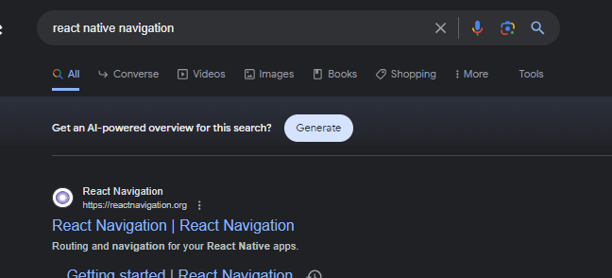

Click on Docs

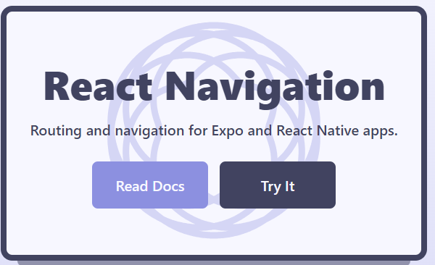

* **Install these Libraries**

**>>> npm install @react-navigation/native**

**>>> npm install react-native-screens react-native-safe-area-context**

**>>> npm install @react-navigation/native-stack**

Step 2

* Create **Project structure**

Create **src** folderin project root folder

Create **components** folder Inside **src**

Create **navigation** folder Inside **src**

Create **screens** folder Inside **src**

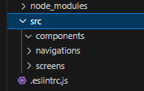

* **Create Screens to navigate**

Create **Splash.js , Home.js** and **About.js**

Inside **Screens** folder

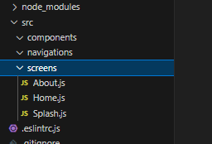

* Create **Routs** for Navigation

Create **Routs.js** inside **navigation** folder

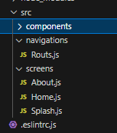

Step 3

* Setup **Navigations**

Add **Routs.js**  inside **App.js**

**App.js**

import React from 'react'

import Routs from './src/navigations/Routs'

const App = () => {

  return (

      <Routs />

  )

}

export default App

Step 4

* Setup All Screens for Routing inside **Routs.js**

**Routs.js**

import React from 'react'

import { NavigationContainer } from '@react-navigation/native'

import { createNativeStackNavigator } from '@react-navigation/native-stack'

import Splash from '../screens/Splash'

import Home from '../screens/Home'

import About from '../screens/About'

const stack = createNativeStackNavigator()

const Routs = () => {

  return (

    <NavigationContainer>

      <stack.Navigator

        initialRouteName='Splash'

        screenOptions={{ headerShown: false }}

      >

        <stack.Screen name="Splash" component={Splash} />

        <stack.Screen name="Home" component={Home} />

        <stack.Screen name="About" component={About} />

      </stack.Navigator>

    </NavigationContainer>

  )

}

export default Routs

Step 5

* In **Splash.js** Add 2 **Buttons** . **Home** and **About** to Navigate

**Splash.js**

import { Button, StyleSheet, Text, View } from 'react-native'

import React from 'react'

const Splash = (props) => {

  const navigateToHome = () => {

    props.navigation.navigate('Home')

  }

  const navigateToAbout = () => {

    props.navigation.navigate('About')

  }

  return (

    <View>

      <Text style={{ color: "black",fontSize: 40,textAlign: "center",

      }} >

        Splash

      </Text>

      {/* Navigation Home Button */}

      <View style={{ marginTop: 10 }}>

        <Button title="Home" color="#841584"

          onPress={navigateToHome}

        />

      </View>

      {/* Navigation About Button */}

      <View style={{ marginTop: 10 }}>

        <Button title="About" color="#841584"

          onPress={navigateToAbout}

        />

      </View>

    </View>

  )

}

export default Splash

Step 6

* In **Home.js** . Add 2 **Buttons** . **Splash** and **About** to Navigate

**Home.js**

Step 7